Book

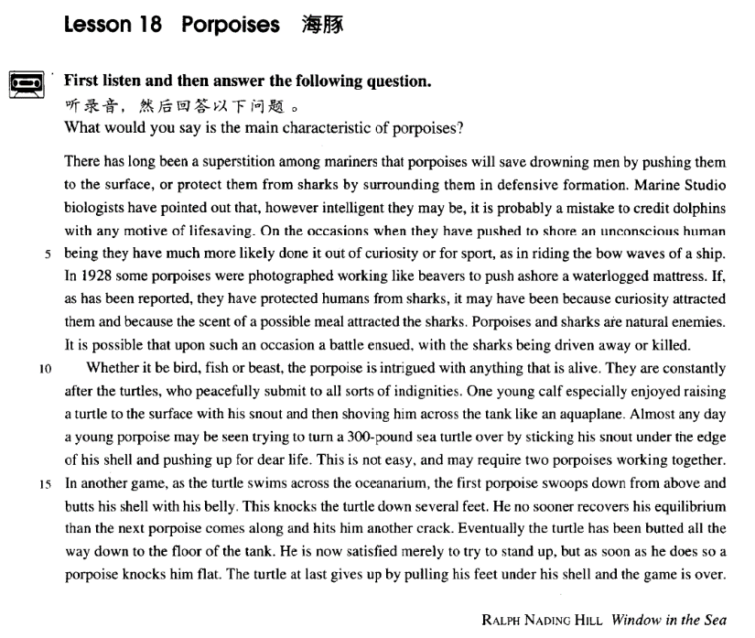

课文

There has long been a superstition among mariners that porpoises will save drowning men by pushing them to the surface, or protect them from sharks by surrounding them in defensive formation.

长期以来，海员中流传着一种迷信的说法，认为海豚会把快要淹死的人托到水面，救人性命；或在人们周围列队保护，使他们免遭鲨鱼伤害。

Marine Studio biologists have pointed out that, however intelligent they may be, it is probably a mistake to credit dolphins with any motive of life-saving.

海洋摄影室的生物学家指出，无论海豚多么聪明，认为它们有救人的动机可能是错误的。

On the occasions when they have pushed to shore an unconscious human being they have much more likely done it out of curiosity or for sport, as in riding the bow waves of a ship.

当它们偶尔把一个失去知觉的人推到岸边时，更大的可能是出于好奇或游戏，就像它们追逐被船首犁开的浪花一样。

In 1928 some porpoises were photographed working like beavers to push ashore a waterlogged mattress.

1928年，有人拍摄到了海豚像海狸一样把浸透水的床垫推上岸的情景。

If, as has been reported, they have protected humans from sharks, it may have been because curiosity attracted them and because the scent of a possible meal attracted the sharks.

正如报道中所说，如果海豚保护人不受鲨鱼侵害，那么它们可能是出于好奇；而鲨鱼可能是闻到了可以美食一顿的香味。

Porpoises and sharks are natural enemies.

海豚和鲨鱼是天然仇敌，

It is possible that upon such an occasion a battle ensued, with the sharks being driven away or killed.

双方可能随之发生搏斗，搏斗结果是海豚赶走或咬死鲨鱼。

Whether it be bird, fish or beast, the porpoise is intrigued with anything that is alive.

海豚对凡是活的东西都感兴趣，不管是鸟、是鱼，还是野兽。

They are constantly after the turtles, who peacefully submit to all sorts of indignities.

它们经常追逐海龟，海龟则温顺地忍受着各种侮辱。

One young calf especially enjoyed raising a turtle to the surface with his snout, and then shoving him across the tank like an aquaplane.

一只小海豚特别喜欢用鼻子把海龟推到水面，然后像滑水板一样把海龟从水池的这一边推到那一边。

Almost any day a young porpoises may be seen trying to turn a 300-pound sea turtle over by sticking his snout under the edge of his shell and pushing up for dear life.

几乎每天都可以看到一只小海豚把鼻子顶入一只300磅重的海龟的硬壳下面，拼命地把它翻过来。

This is not easy, and may require two porpoises working together.

这并非易事，可能需要两只海豚合伙干才行。

In another game, as the turtle swims across the oceanarium, the first porpoise swoops down from above and butts his shell with his belly.

在另一场游戏中，当海龟游过水族馆时，第一只海豚从上方猛扑下去，用腹部撞击龟壳。

This knocks the turtle down several feet.

这一下子把海龟撞下去好几英尺。

He no sooner recovers his equilibrium than the next porpoise comes along and hits him another crack.

海龟刚恢复平衡，第二只海豚又冲过来猛击一下。

Eventually the turtle has been butted all the way down to the floor of the tank.

这只海龟最终被撞到池底。

He is now satisfied merely to try to stand up, but as soon as he does so a porpoise knocks him flat.

此时的海龟，只要能站起来就满足了，但它刚站起来，就被一只海豚击倒。

The turtle at last gives up by pulling his feet under his shell and the game is over.

海龟终于屈服了，将4条腿缩进壳内。游戏到此结束。

词汇讲解

### porpoise

* **porpoise** ['pɔ:pəs] n. 鼠海豚

**porpoise** 鼠海豚

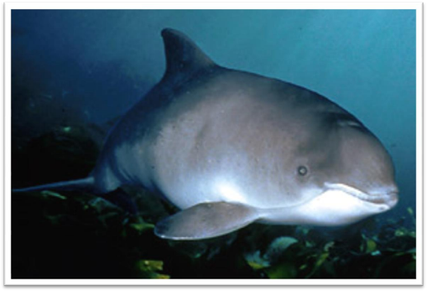

**dolphin** 海豚

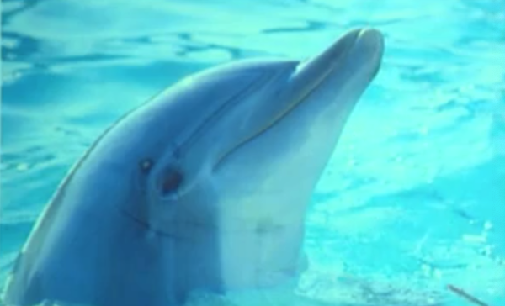

**【扩展】**“海洋”相关：

**shark** 鲨鱼

* **shark**-infested waters 布满鲨鱼的海域

**beaver** 海狸

**marine** adj.海洋的

* **marine** life / mammals / products

**mariner** 水手

**sailor** / **seaman** 水手

**maritime** 海的

* **maritime** museum / law / climate

**oceanarium** 海洋馆

**aquatic** n. 水上运动；水生植物或动物；adj. 水生的；水栖的；在水中或水面进行的

* **aquatic** sports 水上运动
* **aquatic** life 水生生物

【词根】

‘**aqua**’= **water**

**aqualung** 水肺

**Aquarius** 水瓶座

**aquaplane** 滑水板

**aquarium** 水族馆，水族箱

‘**hydr’** = **water**

**hydrant**

**hydrophobia**

**dehydrate**

* **dehydrated** vegetables

【词根】

‘**ium’** 某个场所

**stadium** 露天体育场

**gymnasium** 体育馆，健身房

**auditorium** 礼堂

### formation

* **formation** [fɔ:'meɪʃn] n. 形成，组成；队形，阵形
* the **formation**（形成） of a new government
* the **formation**（形成） of children's personalities
* The soldiers advanced **in** close **formation**（队形，阵形）.
* The team usually plays in defensive **formation** / attacking **formation** / offensive **formation** / a 4-4-2 **formation**. （队形，阵形）

**【近似词】**

**information** n. 信息，资料；知识；情报；通知

**reformation** n. 革新；改善

* economic **reformation**

**deformation** n. 变形

* **deformation** of surface

**malformation** n. 畸形；变形

* congenital **malformation**

**transformation** n. （彻底的）变化，改观，转变，改革

* Nixon’s visit led to a **transformation** of American attitudes toward China.

### waterlogged

* **waterlogged** ['wɔ:təlɒgd] adj. 浸满水的
* The game was cancelled because of the **waterlogged** pitch.

**【近义词组】**表达“**浸满水的**”：

**be soaked / dripping / drenched with …**

* I’m **~~~~** with sweat.

**【近义词】**表达“潮湿的”：

**wet** 湿（内部、外部）

* Her hands were **wet**.
* a **wet** sponge

**moist** （褒义）潮湿的

**damp** （贬义）潮湿的

* Bring me a **moist** towel.
* a cold, **damp** collar

### scent

* **scent** [sent] n. 香味（天然的）

**【近义词】**表达“**香味（天然的）**”：

**scent**

**perfume**

**fragrance**

* the **scent** of ripe fruit
* the **perfume** of flowers
* the **fragrance** of lilacs
* **Scent** Of A Woman
* the **Fragrant** Hills

**【扩展】【近义词】**表达“**味（非天然的）**”：

**aroma** n. 芳香

* the **aroma** of hot coffee

**smell** 臭味

* funny **smell**

**smelly** 有难闻气味的；有臭味的

**smelly** feet

**odour** / **odor** （尤指难闻的）气味；臭味

* body **odour** / **odor**

**odourless** / **odorless** adj. 无气味的；无臭的

* Carbon monoxide is a colorless, **odorless** and noxious gas.

### ensue

* **ensue** [ɪn'sju:] v. 随之发生，因而发生
* I objected what he had just said and a heated argument **ensued** (**from** it).

**【近义词组】**表达“**随之发生**”：

**come after …**

* The Napoleonic Wars **came after** the French Revolution.

**in the wake of …**

* **In the wake of** Thailand’s economic troubles, Malaysia’s currency also sank.

**go hand in hand with …** 两件事伴随出现

* Wealth often **goes hand in hand with** power.

**coincide with …** 碰巧同时发生

* His arrival **coincided with** my departure.

### intrigue

* **intrigue** [ɪn'tri:g] v. 引起兴趣，激起好奇心

**intrigue** vt. **英文解释：**arouse sb.’s interest or curiosity, usually because sth. is unusual

* What you say **intrigues** me. Tell me more.

**【近义词组】**表达“**引起某人兴趣**”：

**interest sb.**

**appeal to sb.**

**arouse one’s interest / curiosity**

**【其他含义】**表达“**阴谋**”：

**intrigue with sbA. against sbB.** 与A耍阴谋对付B

* He was **intriguing with** the barons **against** the king.

**【名词含义】**

**intrigue** n. **阴谋**；**诡计**；复杂的事；私通

**scheme** n. 计划；组合；体制；**诡计**

* **schemes** and **intrigues**
* All the imperialist **schemes** and **intrigues** are doomed to failure.

### shove

* **shove** [ʃʌv] v. 猛推
* Everyone was pushing and **shoving**, all the way to the gate.

**【扩展】**

**butt** （动物）用头（或角）顶

* The goat butted him in the stomach.

**gnaw**  咬；啃；啮

* A rat is **gnawing (at)** the cable.

**pounce on …**猛扑；突袭

* The tiger **pounced on** the goat.
* He had spotted a tiny bottle at the bottom of my case and he **pounced on** it with delight.

**swoop on …** （尤指为了袭击）向下猛冲，俯冲

* We saw the hawk **swoop on** its prey.

### equilibrium

* **equilibrium** [7i:kwɪ'lɪbriəm] n. 平衡

**be in equilibrium** 处于平衡

* For the economy to **be in equilibrium**, income must equal expenditure.

**upset the equilibrium** 打破平衡

**restore / recover equilibrium** 恢复平衡

**inner equilibrium** 内心平衡

* Yoga is said to restore one's **inner equilibrium**.

**【同义词】**

**balance**

**strike a balance** 达到平衡

**upset the balance** 打破平衡

* We must **strike a balance** between reckless spending and penny-pinching.
* These creatures have **upset the** delicate ecological **balance** in the lake.

**balanced** adj. 平衡的；和谐的；安定的

* lead a **balanced** life

**【近义词】**

**symmetry** n. 对称（性）；整齐，匀称

* the **symmetry** of her features

**symmetric** / **symmetrical**

* the **symmetric** / **symmetrical** petals

**harmony** n. 协调；和睦；融洽；调和

* racial **harmony**
* domestic **harmony**
* We hope we can live together in **harmony**.

**harmonious** adj. 和谐的，和睦的；协调的；悦耳的

* build a **harmonious** society

**compatible** adj. 兼容的；能共处的；可并立的

* The couple divorced because they were not **compatible**.
* The software isn’t **compatible** with older operating systems.

课文讲解

# （第一段）

# There has long been a superstition among mariners that porpoises will save drowning men by pushing them to the surface, or protect them from sharks by surrounding them in defensive formation.

**语法分析：**

There has long been a superstition *among mariners（状语，前置）* **that** （**that**... 同位语从句，修饰**superstition**）porpoises will save drowning men *by pushing them to the surface**（方式状语）*, or protect them from sharks *by surrounding them in defensive formation（方式状语）*.

知识点（1）**无灵主语**

* There has long been a superstition among mariners
* 翻译：在海员之中有一个长期的迷信
* **考研阅读：**
* While the quality of legal journalism varies greatly, there is an undue reliance amongst many journalists on interpretations supplied to them by lawyers.
* 翻译：很多记者长期依赖律师提供给他们的解释

知识点（2）

**superstition** n. 迷信；迷信的观念

**superstitious**  adj. 迷信的

* foster **superstition** 助长迷信
* break down / abolish **superstition** 破除迷信

知识点（3）【课文仿写】**无灵主语**

* **造句**：中国人长久以来迷信看见喜鹊会有好运气。
* There has long been a superstition among the Chinese that seeing a magpie will bring you good luck / is a good omen **/** is an auspicious omen.

**【扩展】**表达“**不吉利的**”：

**A bad omen**

**An ill omen**

**An ominous omen**

* **造句**：中国人长久以来迷信听见乌鸦叫是不吉利的。
* There has long been a superstition among the Chinese that hearing the crowing of a crow is an ominous omen.

# Marine Studio biologists have pointed out that, however intelligent they may be, it is probably a mistake to credit dolphins with any motive of life-saving.

**语法分析：**

Marine Studio biologists have pointed out that, *however intelligent they may be（让步状语从句）*, it（形式主语）is probably a mistake to credit dolphins with any motive of lifesaving（to … 真正主语）. （that… 宾语从句）

知识点（1）

**studios** （广播、电视的）录音室，录像室，演播室，制作室；（音乐）录音棚；电影公司；电影制片厂

* Universal **Studios**

知识点（2）Lesson03-36

**point out** 指出，提醒注意 （out是副词）

* Franz poured scorn on the idea, **pointing out** that his brother had been killed in action during the war.
* At this, the police **pointed out** ironically that this would hardly be necessary as the men were already under arrest.
* After telling several of his friends about the theft, Dimitri **found out**（out是副词） that his neighbour, Aleko, had suddenly acquired a new lamb.

**【复习】**

**语法**：“**介词+that**”例外，可以看做复合连词

**in that** / **but that** / **except that**

**remark** / **comment** + *on sth. / （介词必须去掉）that …*

知识点（2）

* **课文写法替换：** （让步状语从句）
* **however** intelligent they may be, …
* **no matter how** intelligent they may be, …
* **although** / **though** / **even though** / **while** they may be intelligent, …
* **intelligent *as*** they may be, … （倒装）Lesson03-26

**【复习】**Lesson03-26

**语法：**强调句；让步状语从句中，把被强调的词放到句首；书面语

* **（副词的强调句）**
* **Although** we may **much** pride ourselves on our good taste,
* **Much *as*** *（强调much）*we may pride ourselves on our good taste, we are no longer free to choose the things we want, for advertising exerts a subtle influence on us.
* **Although** I **much** admire Newton as a scientist, I don’t like him as a man.
* **Much *as***I admire Newton as a scientist, I don’t like him as a man.
* **（形容词的强调句）**
* **Although** we may be **proud** of our good taste,
* ... **Proud** ***as*** we may be of our good taste, ...
* **（形容词的强调句）**
* **Although** she is **beautiful**, I still don’t like her.
* **Beautiful** ***as***she is, I still don’t like her. （形容词的强调句）
* **（动词的强调句；动词原形放在句首，原来的位置用助动词代替）**
* **Although** he **tries**, he never seems able to do the work beautifully.
* **Try *as***he does, he never seems to do the work beautifully.
* **（名词的强调句；名词前的冠词去掉，名字放在句首）**
* **Although** he is a **child**, he can make a living.
* **Child *as***he is, he can make a living.

知识点（3）

**credit sth. to …** 归因于…

**【辨析】**

**credit sb. with sth.** 认为某人有某种特征

* **credit** dolphins **with** motive of life saving
* **注意翻译**：加上比较级
* I had **credited** them **with** **more** integrity **than** they showed.
* **翻译**：我原来认为他们**比**他们表现出来的**有更多的**正直 （反话）
* **翻译、直译：**没想到他们这么不正直
* **注意翻译**：加上比较级
* I **credited** you **with** a little **more** sense.
* **翻译：**我原来认为你**有更多的**理性 （反话）
* **翻译、直译：**没想你这么糊涂

知识点（4）

**motive for / behind sth.** 做某事的动机

* the **motive for** the murder
* the **motive behind** the bombing
* Economy is one powerful **motive *for***camping, since after the initial outlay upon equipment, or through hiring it, the total expense can be far less than the cost of hotels.

motive of （of引出同位语）

* The **motive for / behind** the bombing is revenge. 做某事的动机
* the motive **of** revenge 复仇这个动机

知识点（5）

**写作**：主张反应模式（claim – response pattern）

**本文：**

claim 声称

denial 否认

reasons for denial 否认的理由

# On the occasions when they have pushed to shore an unconscious human being they have much more likely done it out of curiosity or for sport, as in riding the bow waves of a ship.

**语法分析：**

On the occasions（时间状语） when they have pushed to shore（状语前置） an unconscious human being（when...定语从句，修饰occasions） they have much more likely done it *out of curiosity（原因状语）* or *for sport（原因状语）*, *as in riding the bow waves of a ship**（方式状语从句，省略了主句出现的成分）*.

知识点（1）

**on / upon … occasion** 某事发生的时刻、场合

* **on** such / rare **occasions** 在这种场合/在罕见的场合
* Mendoza met Humphries in the ring **on a later occasion** and he lost for a second time.
* It is possible that **upon such an occasion** a battle ensued, with the sharks being driven away or killed.

**【扩展】**表达“**情况**”：

**instance**

* **In most instances**（在大多数情况中）, there will be no need for further treatment.

**circumstance**

* **Under no circumstances**（在任何情况下） should you approach that man.

知识点（2） Lesson04-01

语法、写作：改变正常语序

* … they have pushed an unconscious human being *to shore* …
* … they have pushed *to shore* an unconscious human being …
* **考研英语（英译汉）：**
* His function is analogous to that of a judge, who must accept the obligation of revealing *in as obvious a manner as possible*the course of reasoning *which led him to his decision*. （宾语后置）
* … we have to lower *into the ground* and haul *out of the ground* great lengths of drill pipes *which are rotated by an engine at the top and are fitted with a cutting bit at the bottom*. （宾语后置）
* **造句**: 请把我们急需的那个软件从网站上下载下来然后通过e-mail 发送给我。
* Please **download** *from the website*and **send** *to me by email*the software of which we are in urgent need.

知识点（3）

**out of …** 出于…

* **out of** interest
* **out of** necessity
* **out of** sympathy / pity
* **out of** respect
* **out of** conscience
* **out of** desperation
* I’m turning to you **out of desperation**.
* **out of** fear
* So let us begin anew—remembering on both sides that civility is not a sign of weakness, and sincerity is always subject to proof. Let us never negotiate **out of fear**, but let us never fear to negotiate. ——John F. Kennedy

知识点（4）

**sport** 乐趣

* Modern alpinists try to climb mountains by a route which will give them good **sport**, …

**for fun / pleasure / amusement** 为了乐趣

知识点（5）

**语法**：状语从句的省略

* **课文补全：**主语成分省略
* On the occasions when they have pushed to shore an unconscious human being they have much more likely done it out of curiosity or for sport, as (they have done it out of curiosity or for sport) in riding the bow waves of a ship.

**as** (书面语中)表示“像…一样”一定是**连词**

* Air is to man **as** water is to fish.
* **老托福语法改错题：**
* In New York, like（X错误） in some other cities, environmental pollution is becoming more and more serious.
* In New York, **as** in some other cities, environmental pollution is becoming more and more serious. √
* In New York, as environmental pollution is becoming more and more serious (补全) in some other cities, environmental pollution is becoming more and more serious.
* It is almost always due to some very special circumstances that traces of land animals survive, **as** by falling into inaccessible caves, or into an ice crevasse, **like** the Siberian mammoths, when the whole animal is sometimes preserved, **as** in a refrigerator.
* It is almost always due to some very special circumstances that traces of land animals survive, as traces of land animals survive(补全) by falling into inaccessible caves, or into an ice crevasse, like the Siberian mammoths, when the whole animal is sometimes preserved, as the whole animal is preserved(补全) in a refrigerator.

# In 1928 some porpoises were photographed working like beavers to push ashore a waterlogged mattress.

**语法分析：**

In 1928（时间状语） some porpoises were photographed *working like beavers to push ashore（状语前置） a waterlogged mattress*（目的状语）. （*working*...主语补足语）

知识点（1）

**photograph sb. doing sth.** 拍下某人正在做某事

* They **were photographed** playing with the children.

知识点（2）

**beaver** n. 海狸；海狸皮毛

* an eager **beaver** 干活特别卖力的人；对工作极有热忱的人

知识点（3）

**mattress** 沉排；用埽料或土工织物构成柔性排体，上压重物，或用混凝土条形构件连成排体，用于护岸、护脚的工程。

注：课文翻译错误

# If, as has been reported, they have protected humans from sharks, it may have been because curiosity attracted them and because the scent of a possible meal attracted the sharks.

**语法分析：**

If, as has been reported, they have protected humans from sharks（if... 条件状语从句）, it may have been *because curiosity attracted them**（because… 表语从句1）* and *because the scent of a possible meal attracted the sharks（because… 表语从句2）*.

知识点（1）Lesson03-33 非限定定语从句 定语从句知识点（4-1）

**语法**：as引导的非限定定语从句修饰整个句子

* **课文举例：**
* Things can go wrong on a big scale, **as** （关系代词，非限定性定语从句，关系代词做discovered的宾语） a number of people recently discovered in Parramatta, a suburb of Sydney.
* **As** （关系代词，非限定性定语从句，关系代词做explained的宾语） the Commanding Officer explained later, one half of the station did not know what the other half was doing!
* If, **as**（关系代词，非限定性定语从句，关系代词做主语） has been reported, they have protected humans from sharks, it may have been because curiosity attracted them and because the scent of a possible meal attracted the sharks.
* **As**（关系代词，非限定性定语从句，关系代词做主语） is so often pointed out, knowledge is a two-edged weapon which can be used equally for good or evil.

**【辨析】**

**语法**：as 引导的非限定性定语从句与 which 引导的非限定性定语从句的区别。

1、as 作为关系代词指代整个主句，而 which 作为关系代词指代整个主句或先行词均可。

2、as 引导的非限定性定语从句位于主句前、中、后均可，而which 引导的非限定性定语从句不能位于主句之前。

* As a poet points out, life is but a dream.
* Children, as is always the case, love their mother.
* She became angry, as many could see.

**3、**as 引导的非限定性定语从句含有“众所周知”的意思，常译为“正如……”，而which 引导的非限定性定语从句则未必有这个意思。

* The sun heats the earth, which makes it possible for plants to grow.（不能换成as，没有“正如”的含义）

**4、**在“as + is/was + done”结构中可省略“is/was”，而在 “which + is/was + done”可省略“which + is/was”，而不能只省略 be 动词。

* As (is) reported, a foreign delegation will visit the city.
* a puma (which was) at large
* **课文简写：**
* If, **as reported**, they have protected humans from sharks, …
* **托福语法改错题：**
* As Napoleon once pointed it out, attack is the best method of defense. X多了宾语 （美式认为错误）（英式中认为可以接受，as充当连词，不错宾语）
* As Napoleon once pointed out, attack is the best method of defense. √

**【辨析】**

**语法**：**as** 引导方式状语从句

* **课文写法替换：**非限定性定语从句
* Cave exploration, or pot-holing, **as ~~(it)~~ has come to be known**, is a relatively new sport.
* The problem, **as** I see *it*（方式状语）, is no big deal.
* The author was brought up in a small village, as *it*（方式状语）is recounted in some of his stories.

知识点（2）Lesson04-03 定语从句知识点（3）

**语法**：**限定性定语从句**；先行词如出现such / the same / as / so 后面的关系代词用as，不用which和that

**such / the same / as / so … as …**

* I need ***the same***tool **as** you are using.
* I need ***such***a tool **as** you are using.
* I need ***as***useful a tool **as** you are using.
* ***Such*** inns **as** there were（限定性定语从句，修饰先行词inns，用as和such固定搭配） were generally dirty and flea-ridden; the food simply local cheese accompanied by bread often twelve months old, *all washed down with coarse wine*.

知识点（3）Lesson03-50

**it is because …**               原因是…（主系表）

**the reason is that …**     原因是…

**…, the only reason is that …** 原因是…

The reason is because … **☓表达错误，reason和because重复**

* **课文写法替换：**
* … it may have been because curiosity attracted them …
* … **the reason** may have been **that** curiosity attracted them …

# Porpoises and sharks are natural enemies.

知识点（1）

natural enemies 天敌

* This rabbit had no **natural enemies** in the Antipodes, …

# It is possible that upon such an occasion a battle ensued, with the sharks being driven away or killed.

**语法分析：**

it（形式主语）is possible that upon such an occasion a battle ensued, with the sharks being driven away or killed（独立主格，做状语）. （that...主语从句）

# （第二段）

# Whether it be bird, fish or beast, the porpoise is intrigued with anything that is alive.

**语法分析：**

Whether it be（让步状语从句中，be型虚拟） bird, fish or beast（让步状语从句）, the porpoise is intrigued with anything that is alive（定语从句）.

知识点（1）

**语法**：让步状语从句中，be型虚拟

* **普通表达：**
* Whether it **is** bird, fish or beast, ……
* **be型虚拟：**
* After all, all living creatures live by feeding on something, whether it **be** plant or animal, dead or alive, and it is only by chance that such a fate is avoided.
* Whether she **be** right or wrong, she will have my unswerving support.
* Though he **be** the President himself, he shall listen to us.
* **be型虚拟：be放在句首**
* **Be** it bird, fish or beast, ……
* Home is home, **be** it ever so homely.
* Home is home, though it **be** ever so homely.
* **Gre写作范文：**
* Once the educators, **be** they administrators or teachers, are under the control of students, even a democratic situation would be like holding royalty accountable to the mob.
* Once the educators, whether they **be** administrators or teachers, are under the control of students, even a democratic situation would be like holding royalty accountable to the mob.

# They are constantly after the turtles, who peacefully submit to all sorts of indignities.

**语法分析：**

They are constantly after the turtles, who peacefully submit to all sorts of indignities（who...定语从句，充当并列句）.

知识点（1）

**be after …** 追逐；追捕；想抓住或得到……

* The police **are after** the fugitive.
* He’**s afte**r my job.
* I’m sure she’**s after** my husband.

知识点（2）

**submit to …** 服从……；屈服于……；甘心忍受……

* All countries in the EU must **submit to** its laws.
* I’m not prepared to **submit to** this painful course of treatment.
* First, you must give Helen back to my brother. Second, Troy must **submit to my command** to fight for me whenever I call.

**【近义词组】**表达“服从……；屈服于……；甘心忍受……”：

**bow to …**

* The government refused to **bow to** terrorists.

**yield to …**

**succumb to …**

**be subject to …**

* All employees **are subject to** the regulations of the company.
* So let us begin anew—remembering on both sides that civility is not a sign of weakness, and sincerity **is** always **subject to** proof. Let us never negotiate out of fear, but let us never fear to negotiate. —— John F. Kennedy

# One young calf especially enjoyed raising a turtle to the surface with his snout, and then shoving him across the tank like an aquaplane.

知识点（1）

**calf** 大型动物的幼崽

**foal** 驹子；小马驹；小驴子

**piglet** 猪仔；小猪

**lamb** 羔羊；小羊

**kid** 小孩；小山羊

**fawn** （不足一岁的）幼鹿

**cub** （熊、狮、狐狸等的）幼兽，崽

**kitten** 小猫

**puppy** 小狗；幼犬

**chicken** 小鸡

**duckling** 小鸭子

**gosling** 小鹅；年轻无知者

**larva** 幼虫；幼体

**infant** 婴儿；幼儿

# Almost any day a young porpoises may be seen trying to turn a 300-pound sea turtle over by sticking his snout under the edge of his shell and pushing up for dear life.

**语法分析：**

Almost any day a young porpoise may be seen（see doing 固定搭配） trying to turn a 300-pound sea turtle over *by sticking his snout under the edge of his shell and pushing up for dear life*. （*by*... 方式状语）

知识点（1）

**stick sth.** 伸出去

* **Stick**’em up! 举起手来
* **Stick** your tongue. 伸出舌头

知识点（2）

**for dear life** 拼命地……

**【辨析】**

**for life** 终生，一辈子

* The accident left her scarred **for life**.

# This is not easy, and may require two porpoises working together.

# In another game, as the turtle swims across the oceanarium, the first porpoise swoops down from above and butts his shell with his belly.

# This knocks the turtle down several feet.

# He no sooner recovers his equilibrium than the next porpoise comes along and hits him another crack.

知识点（1）

* **课文写法替换：部分倒装**
* **No sooner *does***he recover his equilibrium **than** the next porpoise comes along and hits him another crack.

# Eventually the turtle has been butted all the way down to the floor of the tank.

# He is now satisfied merely to try to stand up, but as soon as he does so a porpoise knocks him flat.

知识点（1）

**be satisfied with / to do …** 做某事很满意

**be content with / to do …**  对某事很满意

知识点（2）

* **课文写法替换：部分倒装**
* …, but **no sooner *does***he do so **than** a porpoise knocks him flat.

# The turtle at last gives up by pulling his feet under his shell and the game is over.